Current Pages:

**castVote:**

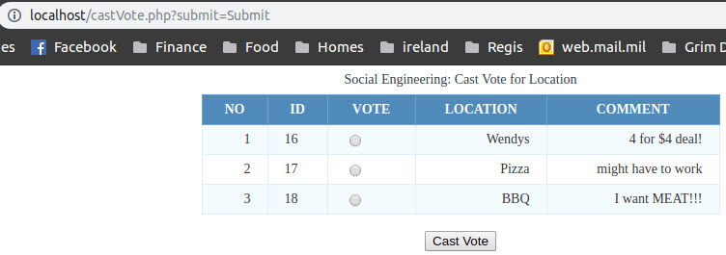

On castVote, users will see a list of the options where they can meet up and vote for their favorite.

**submitOptions:**

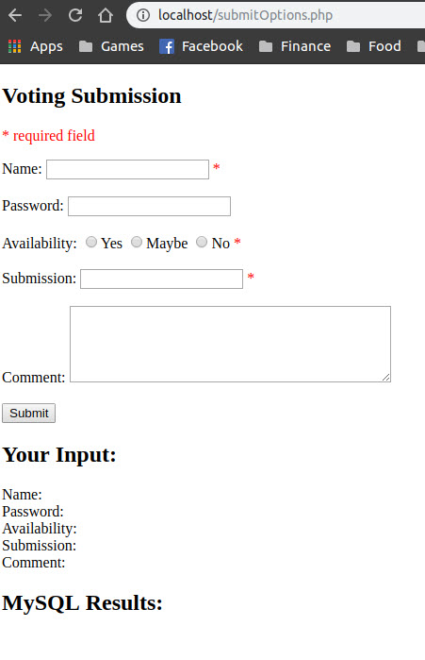

submitOptions is where users go to enter their suggestions for where to eat/meet up, if they can attend, and what they would like to do there.

NOTE: I added the ‘Your Input’ and ‘MySQL Results’ sections to show what would be entered into the database without having the sql backend. SQL results will most likely fail because it’s looking for a specific DB name in the function.

**userSuggestions:**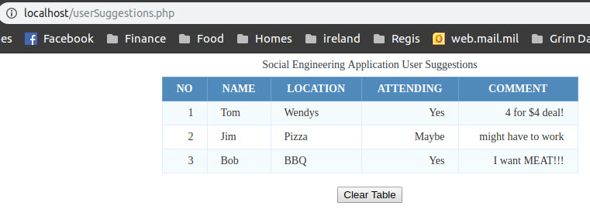

The userSuggestions page is a quick view listing the suggestions that have been offered, who suggested them, if they are attending, and their comments. It currently has a button that will clear the SQL database when clicked. The idea behind that is, the table should be cleared every time a new event is started.